From : Foundation Vader Kennis Centrum (VKC), Netherlands
Email : secretariaat@vaderkenniscentrum.nl
To : Special Rapporteur on violence against women and girls,
its causes and consequences
Subject : Input by VKC for SR VAWG's report on violence against
women and children in custody cases
Date : December 15, 2022
Our reference : 221215.UN.SR-VAWG

Input by VKC for SR VAWG's report on violence against women and children in custody cases
By the Special Rapporteur on violence against women and girls, its causes and consequences

Foundation Vader Kennis Centrum (Father Knowledge Centre) is a parent organization and NGO from the Netherlands working for children’s rights, gender equality, shared equal and positive parenting and care for children, involved and engaged fatherhood and fatherinclusive policies and practices. In our board we decided to respond to your call for input.
We do not support the report because it is not promoting gender equality as it is strongly biased in favor of women, which cannot lead to the solution to the domestic violence problem. Our main points to object to the report are the following.
First, parental alienation is real and denying it is leading to increasing cases of alienation or similar malevolent behavior of one parent towards another parent and especially their children. We believe that parental alienation or similar behavior is emotional abuse of children and therefore psychological violence towards children and the alienated parent. Denying it and even trying to turn it opposite as if the allegations of parental alienation is a kind of violence (against women), is leading to the re-victimization of alienated parents and prevents help to alienated children, who are deprived of contact with previously loved parents. Also, we never heard of any case where allegations of parental alienation caused moving children into the custody of the alienated parents. On the other side, we know of a lot of cases where one parent (usually the father) is first falsely accused of domestic violence or abuse, and then alienated from his children, who after the manipulation of the alienating parent start to reject contact with him. We are also aware of the serious psychological problems alienated children have, not only in their childhood but also in later adult life.
Second, the report is not mentioning men as victims of domestic violence or abuse. We are aware that this is happening and neglecting it in the report is an attempt to demonize men and fathers as the only ones responsible for the violence. This is simply not true and yet there is not a word about it.
Third, the Istanbul convention is rather discriminatory towards men. We don’t know how it came into reality, but it was hidden from the eyes of the public when some ‘group of experts’ was preparing it. Then it was accepted by the EU institutions, and later by member countries, and in many also ratified - all of these processes were more or less again hidden from the public eyes, and calls for changing it were unheard. Now it is hard to step out of this convention, and everyone who tries to point out its faults is labelled as a “violator of women’s rights”, a “perpetrator” or a “protector of violent men”.
As a foundation, we have been committed to permanent and equal parenting for many years and we have supported both men and women in this process. In helping men, however, we have for years experienced prejudices with which Dutch government organizations justify decimating the role of fathers in society by largely excluding them from their children.
As a Foundation, we are against any form of violence and are well aware that much is still needed worldwide to prevent violence against women and girls. However, these efforts in the Western world seem to be overshooting their mark. Efforts to prevent violence against women and girls in the Western world have progressed to a free pass for women (and sometimes girls) to be above the law. The decades of experience of the VKC Foundation show that accusing men/boys by women/girls pays off and that, without independent investigations, men/boys are now convicted and put away as perpetrators both in the media and by government organizations.
After discussions with representatives of the Dutch Public Prosecution Service and the Dutch National Police, we have found that no action is taken by these organizations if mothers (women) withdraw the children from the parental authority of their fathers (men) (i.e. parental child abduction), which is a criminal offense for which in the Netherlands, a prison sentence of 6 to 9 years has been imposed by law. But as of yet no prosecution of this crime by the Dutch investigative authorities has taken place. However subsequently and instead fathers in fact are prosecuted for stalking, an offense punishable by a prison sentence of up to 3 years when the father whose children have been abducted and kept away by their mothers, looks for contact with them.
This and other examples indicate that the position of women in the Netherlands has been emancipated to such an extent that she is above the law. Figures from the Dutch Center for International Child Abduction (IKO) show that for decades more than 70% of international child abductions have been committed by mothers. Despite these concrete figures, the media and the investigative authorities pay particular attention to international child abductions by fathers.
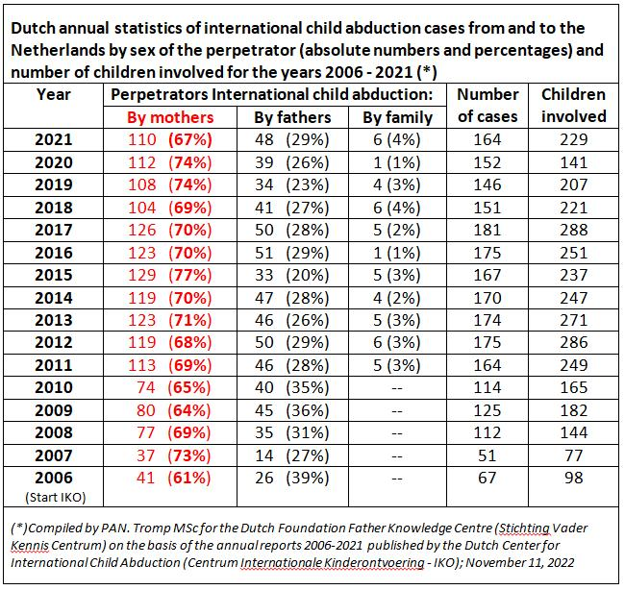
In a letter dated 13 October 2014, the State Secretaries of the Dutch Ministry of Justice and Security and the Dutch Ministry of Health, Welfare and Sport stated that:
“the behavior of the parents when the parental access arrangement is not complied with may be accompanied by, or also include, serious emotional neglect of the child, which may lead to psychological abuse.”
-and-
by letter dated October 22, 2018, the Dutch Minister for Justice and Safety Grapperhaus acknowledged “that withdrawing children from one parent [can] have traumatic consequences for the child and the other parent.”
The consequences of the unequal legal treatment of men can be found in the figures of the Dutch Central Bureau of Statistics: The percentage of children living alone with their mother has hardly changed in the years 1996 to 2015 and is around 90% compared to 10% with their father. The consequences of growing up in fatherless families have been described, among others, in the book The Boys Crisis (Warren Farrell, Phd and John Gray, Phd):
Child abuse as part of domestic violence:
The Dutch Domestic Violence and Child Abuse Instruction 2016 shows that 35 to 40% (119,000) of the reports relate to violence against young people. The Dutch “National Prevalence Study on Child and Adolescent Abuse” , which includes this figure of 119,000 child abuse cases each year, shows that child abuse is divided into 5 forms: It is striking that, with the exception of sexual assault, there are more reports of women as perpetrators than men in all other forms. Particularly in the case of emotional and physical neglect, the percentage of reports about women as perpetrators is considerably higher than for men.
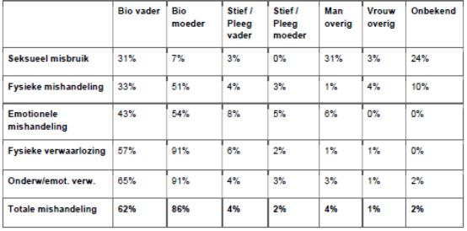
Conclusion:
The foregoing confirms the picture that women in the Western world are just as likely as men to participate in domestic violence. Your report repeatedly refers to victims of domestic violence with the sex-restricted term "women and girls." The proposal never mentions "men and boys" as victims of abuse. This false characterization promotes harmful stereotypes that serve to:
• Preventing male victims from getting help;
• Result in false arrests of male victims, -and-
• Marginalizes the role of fathers for their children;
In our view, this has a very negative effect on equality between men & boys and women & girls which will only further increase "gender discrimination" in violation with the Universal Declaration of Human Rights
As written, VKC strongly suggests rejecting the SR VAWG’s report with the recommendation to prepare a better, gender-inclusive report.
On behalf of the Dutch Foundation Vader Kennis Centrum (VKC),
Kindest regards,

Peter A.N. Tromp MSc
Chair of the board

